 | 1 | Task Description #1 – Linear Search implementation  Task: Write python code for linear_search () function to search a value in a list and extract its index.  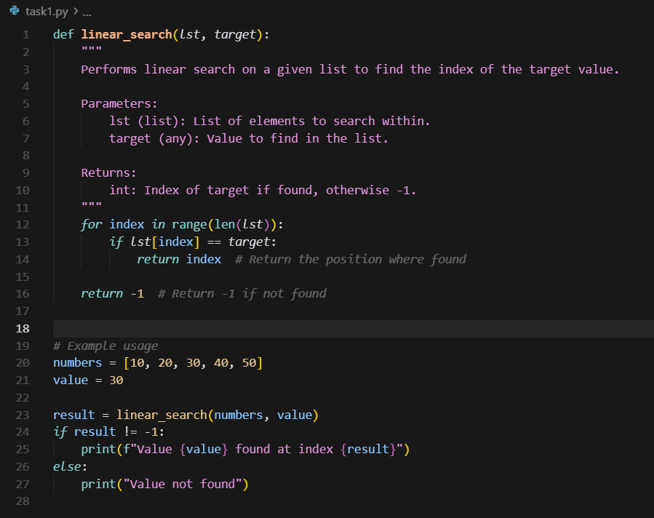  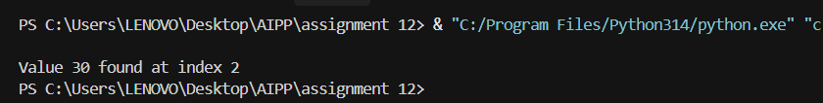  Task Description #2 – Sorting Algorithms  Task: Ask AI to implement Bubble Sort and check sorted output  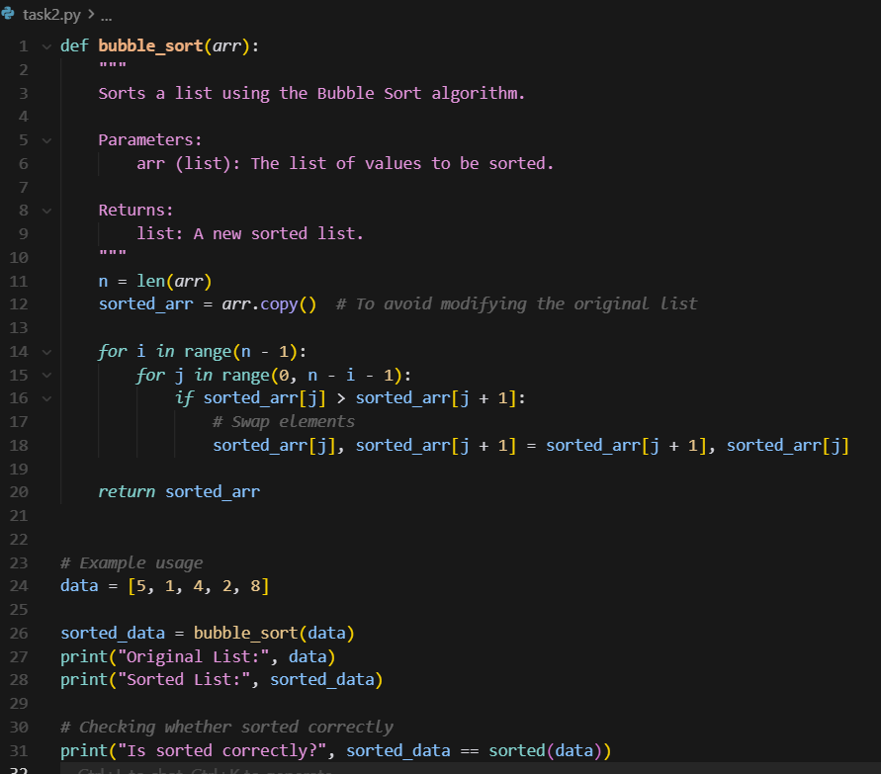  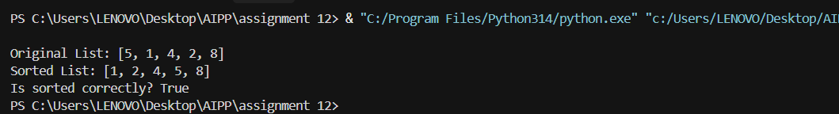  Task Description #3 – Optimization  Task: Write python code to solve below case study using linear optimization    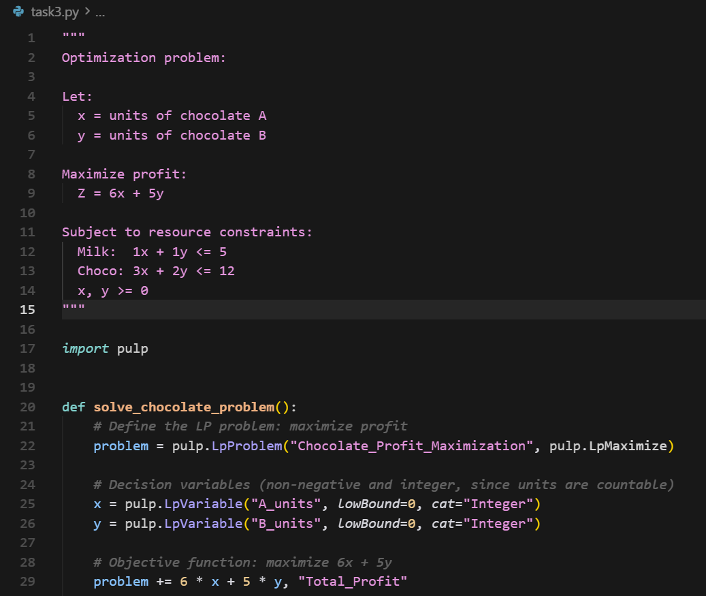  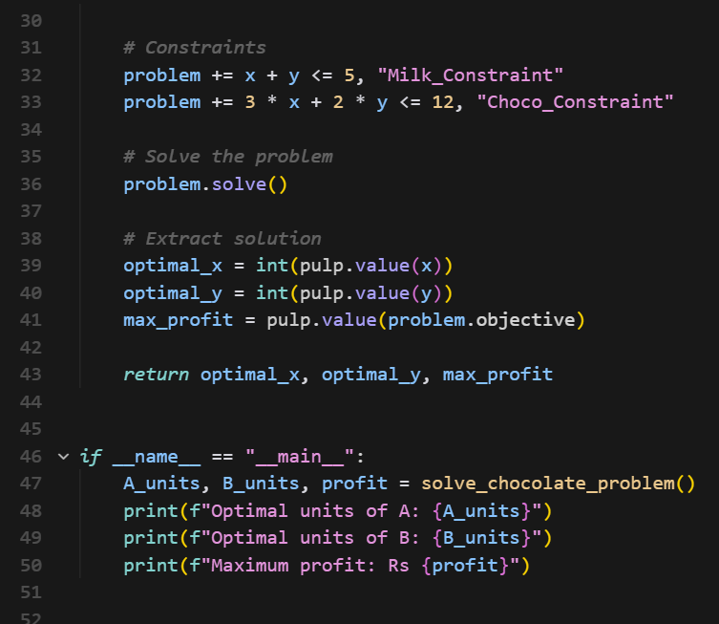  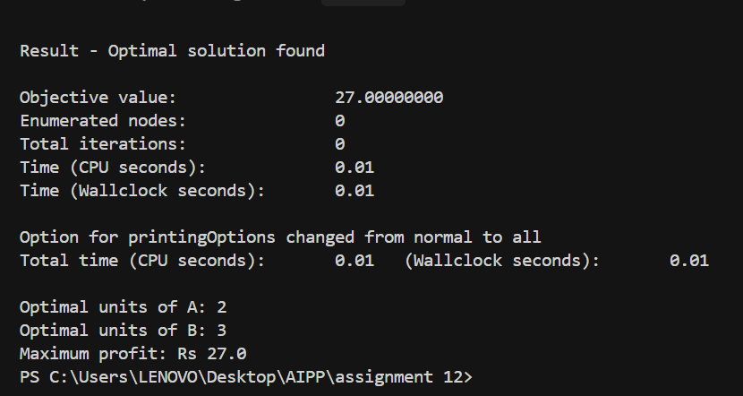  Task Description #4 – Gradient Descent Optimization  Task: Write python code to find value of x at which the function f(x)=2X³+4x+5 will be minimum  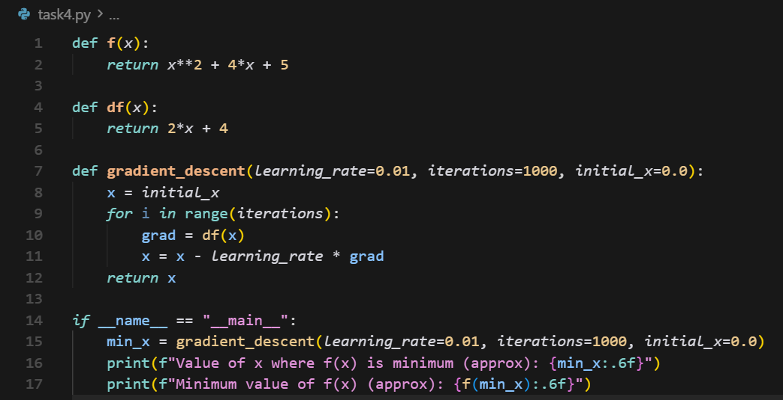  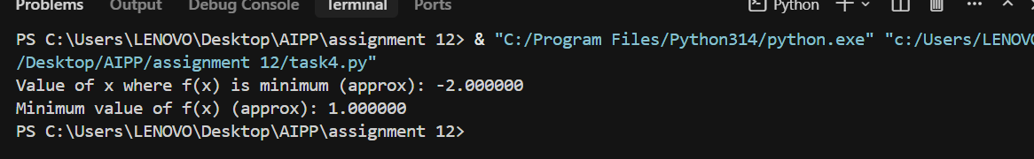 | Week5- Tuesday

